Meeting/Project Name: | Inventory Management
Date of Meeting: (MM/DD/YYYY) | 07/05/2018 | Time: | 08.30 – 09.15 AM
Meeting Facilitator: | Software Engineering Tutorial Session | Location: | BCA Learning Institute A803

1. Meeting Objective
Mendiskusikan game yang akan dikembangkan. Mengetahui requirements yang ditetapkan oleh owner. Menentukan model, tasks, dan deadline tasks.

2. Attendees
Name | Department/Division
Christian Robert | Owner
Heinrich Reagan Salim | Owner
Ricardo Gunawan | Owner
Victor Wijaya | Developer (Project Manager)
Brian Eduardus | Developer
Paula Rona | Developer

3. Meeting Agenda
Topic | Result
Penyampaian ide | (lihat lampiran)
Penyampaian requirement | Backlog :  Sistem game (H)  Design karakter (H)  Main menu, dan interface (M)  Tutorial (M)
Penentuan task dan deadline task | Sistem game, design karakter (07/12/2018)
Penentuan SDLC model | Scrum

4. Pre-work/Preparation (documents/handouts to bring, reading material, etc.)
Description | Prepared by
Sketch | Owner team

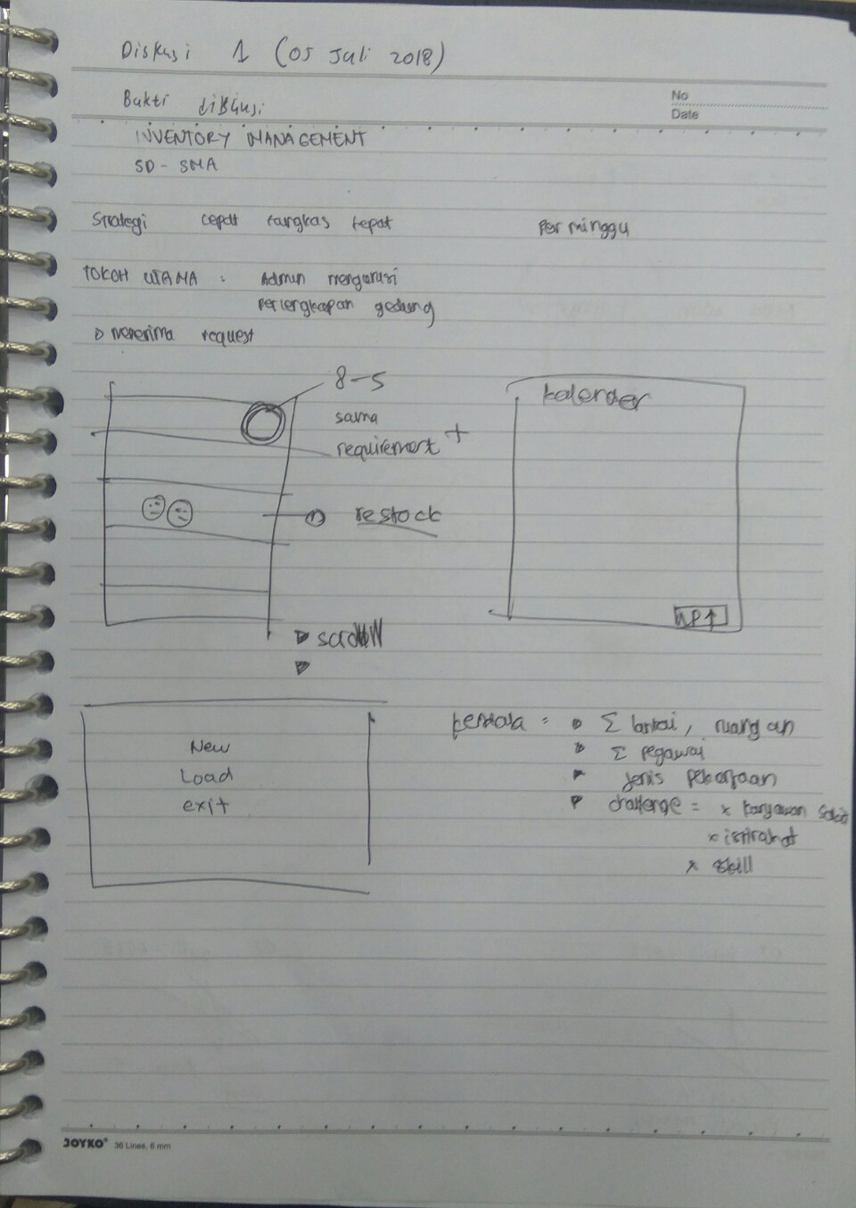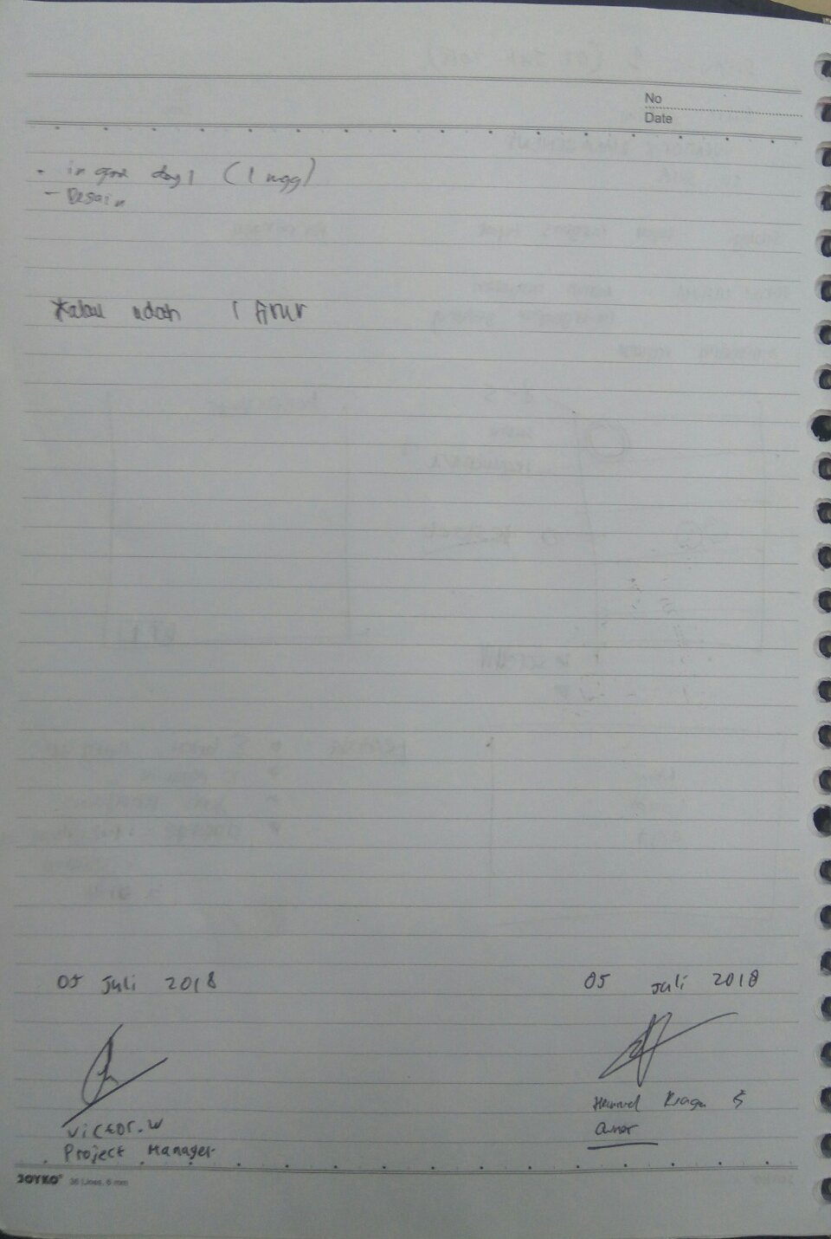

Meeting/Project Name: |  |  | Inventory Management
Date of Meeting: (MM/DD/YYYY) |  |  | 07/11/2018 |  |  |  | Time: |  |  | 13.00 – 14.30 PM
Minutes Prepared By: |  |  | Software Engineering Tutorial Session |  |  |  | Location: |  |  | BCA Learning Institute A803

1. Meeting Objective
Negosiasi SRS dan tarif jasa.Check backlog. Evaluasi dan konsultasi desain interface. Menentukan task dan deadline task selanjutnya

2. Attendance at Meeting
Name |  |  |  |  |  | Department/Division
Christian Robert |  |  |  |  |  | Owner
Heinrich Reagan Salim |  |  |  |  |  | Owner
Ricardo Gunawan |  |  |  |  |  | Owner
Victor Wijaya |  |  |  |  |  | Developer (Project Manager)
Brian Eduardus |  |  |  |  |  | Developer
Paula Rona |  |  |  |  |  | Developer

3. Agenda and Notes, Decisions, Issues
Topic |  |  |  |  |  |  |  |  | Result
Negosiasi SRS |  |  |  |  |  |  |  |  | Revisi SRS
Tarif jasa |  |  |  |  |  |  |  |  | Rp 20.000.000,00 (terinci pada lampiran)
Check backlog |  |  |  |  |  |  |  |  | (lihat nomor 4)
Evaluasi dan konsultasi desain interface |  |  |  |  |  |  |  |  | On progress
Task dan deadline task selanjutnya |  |  |  |  |  |  |  |  | Sistem game, design karakter (07/19/2018)

4. Check Backlog
Question |  |  |  |  |  |  |  |  | Answer
Apa yang sudah dikerjakan |  |  |  |  |  |  |  |  | SRS, desain karakter, main menu
Hambatan yang dihadapi |  |  |  |  |  |  |  |  | belum terlalu mengerti class diagram, belum menguasai construct 2, belum mengerti spesifikasi aplikasi
Apa yang akan dilakukan |  |  |  |  |  |  |  |  | revisi SRS, melanjutkan design, melanjutkan coding dalam construct 2

5. Next Meeting (if applicable)
Date: (MM/DD/YYYY) |  | 07/19/2018 |  | Time: | 08.30 – 09.15 AM |  |  | Location: |  |  | BCA Learning Institute A803
Objective: | Negosiasi ulang tarif, Check backlog. Evaluasi dan konsultasi desain interface. Menentukan task dan deadline task selanjutnya

Rincian tarif Inventory Management Project

Software 10.000.000,00
Listrik 1.000.000,00
Koneksi Internet 1.500.000,00
Gaji 7.500.000,00

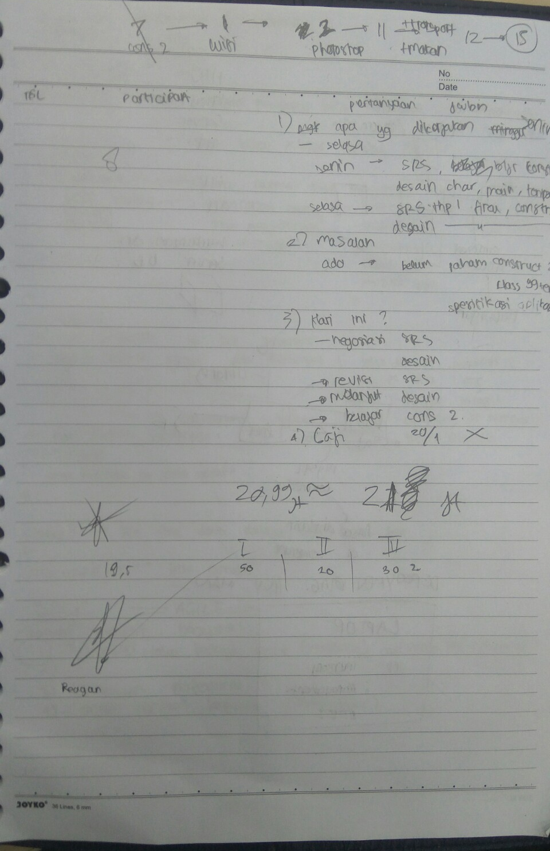
Meeting/Project Name: |  |  | Inventory Management
Date of Meeting: (MM/DD/YYYY) |  |  | 07/25/2018 |  |  |  | Time: |  |  | 13.00 – 14.20 PM
Minutes Prepared By: |  |  | Software Engineering Tutorial Session |  |  |  | Location: |  |  | BCA Learning Institute A803

1. Meeting Objective
Negosiasi ulang tarif, Check backlog. Evaluasi dan konsultasi desain interface. Menentukan task dan deadline task selanjutnya

2. Attendance at Meeting
Name |  |  |  |  |  | Department/Division
Christian Robert |  |  |  |  |  | Owner
Heinrich Reagan Salim |  |  |  |  |  | Owner
Ricardo Gunawan |  |  |  |  |  | Owner
Victor Wijaya |  |  |  |  |  | Developer (Project Manager)
Brian Eduardus |  |  |  |  |  | Developer
Paula Rona |  |  |  |  |  | Developer

3. Agenda and Notes, Decisions, Issues
Topic |  |  |  |  |  |  |  |  | Result
Negosiasi ulang tarif |  |  |  |  |  |  |  |  | Rp 30.000.000,00 (terinci pada lampiran)
Check backlog |  |  |  |  |  |  |  |  | (lihat nomor 4)
Evaluasi dan konsultasi desain interface |  |  |  |  |  |  |  |  | Desain stage, main menu, load, new game, karakter telah selesai dikerjakan
Task dan deadline task selanjutnya |  |  |  |  |  |  |  |  | Sistem game (08/08/2018)

4. Check Backlog
Question |  |  |  |  |  |  |  |  | Answer
Apa yang sudah dikerjakan |  |  |  |  |  |  |  |  | Exit game  Desain stage, main menu, load, new game, karakter  UML selesai kecuali activity dan sequence  Backlog :  Sistem game (H)  Design karakter (H)  Main menu, dan interface (M)  Tutorial (M)
Hambatan yang dihadapi |  |  |  |  |  |  |  |  | Progress coding belum lancar, desain belum sesuai dengan owner
Apa yang akan dilakukan |  |  |  |  |  |  |  |  | Memperbaiki design  Memperbaiki kodingan  Melanjutkan gameplay di stage  Membetulkan uml

5. Next Meeting (if applicable)
Date: (MM/DD/YYYY) |  | 08/08/2018 |  | Time: | 08.30 – 09.15 AM |  |  | Location: |  |  | BCA Learning Institute A803
Objective: | Check backlog. Evaluasi dan konsultasi desain interface. Menentukan task dan deadline task selanjutnya

Rincian revisi tarif Inventory Management Project

Software 15.500.000,00
Listrik 1.000.000,00
Koneksi Internet 1.500.000,00
Gaji 12.000.000,00(UMR Jakarta 3.6 juta)

Meeting/Project Name: |  |  | Inventory Management
Date of Meeting: (MM/DD/YYYY) |  |  | 08/07/2018 |  |  |  | Time: |  |  | 13.00 – 15.00 PM
Minutes Prepared By: |  |  | Self Learning Software Engineering Session |  |  |  | Location: |  |  | BCA Learning Institute A803

1. Meeting Objective
Check backlog. Evaluasi dan konsultasi desain interface. Menentukan task dan deadline task selanjutnya

2. Attendance at Meeting
Name |  |  |  |  |  | Department/Division
Christian Robert |  |  |  |  |  | Owner
Heinrich Reagan Salim |  |  |  |  |  | Owner
Ricardo Gunawan |  |  |  |  |  | Owner
Victor Wijaya |  |  |  |  |  | Developer (Project Manager)
Brian Eduardus |  |  |  |  |  | Developer
Paula Rona |  |  |  |  |  | Developer

3. Agenda and Notes, Decisions, Issues
Topic |  |  |  |  |  |  |  |  | Result
Check backlog |  |  |  |  |  |  |  |  | (lihat nomor 4)
Evaluasi dan konsultasi desain interface |  |  |  |  |  |  |  |  | Desain stage, main menu, load, new game, karakter telah selesai dikerjakan
Task dan deadline task selanjutnya |  |  |  |  |  |  |  |  | Sistem game (08/08/2018)

4. Check Backlog
Question |  |  |  |  |  |  |  |  | Answer
Apa yang sudah dikerjakan |  |  |  |  |  |  |  |  | Exit game  Desain button, icon, stage, main menu, load, new game, karakter  Backlog :  Sistem game (H)  Design karakter (H)  Main menu, dan interface (M)  Tutorial (M)
Hambatan yang dihadapi |  |  |  |  |  |  |  |  | Progress coding belum lancar
Apa yang akan dilakukan |  |  |  |  |  |  |  |  | Memperbaiki kodingan  Melanjutkan gameplay di stage  Membetulkan uml

5. Next Meeting (if applicable)
Date: (MM/DD/YYYY) |  | 08/08/2018 |  | Time: | 08.30 – 09.15 AM |  |  | Location: |  |  | BCA Learning Institute A803
Objective: | Check backlog. Evaluasi dan konsultasi sistem game dan desain interface. Menentukan task dan deadline task selanjutnya

